PROJECT -34
Fill details by 2 triggers(Dental details)
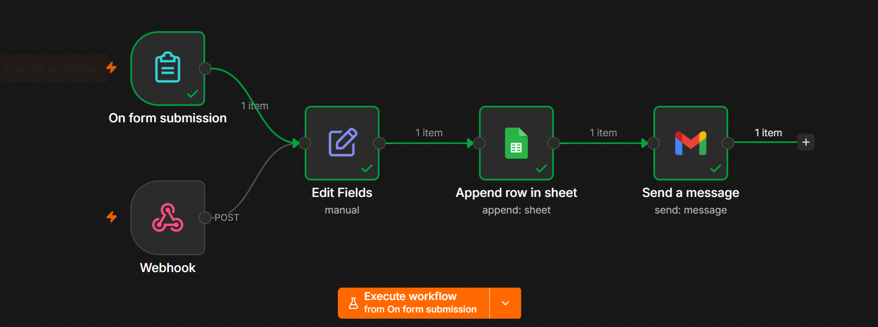

This workflow collects basic patient information (Name, Email, and Age) from a dental registration form. After submission, the data is automatically stored in a Google Sheet, and a confirmation email is sent to the patient.

Workflow Overview
Patient Fills Dental Form
│
▼
On Form Submission
│
▼
Edit Fields
│
▼
Append Row in Google Sheets
│
▼
Send Confirmation Email

Nodes Used
Node | Purpose
On Form Submission | Receives the submitted dental form data
Edit Fields | Renames and formats the submitted fields
Append Row in Google Sheets | Stores patient details in Google Sheets
Gmail | Sends a confirmation email to the patient

Step 1: On Form Submission
Purpose
This node is triggered whenever a patient submits the dental registration form.
Form Fields
Field Name | Type | Required
Name | Text | Yes
Email | Email | Yes
Age | Number | Yes
Example Input
Name:
John Smith

Email:
johnsmith@gmail.com

Age:
28

Step 2: Edit Fields
Purpose
Formats the submitted form data before sending it to Google Sheets.
Field Mapping
Form Field | Output Field
name | Name
email | Email
age | Age
Example Output
{
"Name": "John Smith",
"Email": "johnsmith@gmail.com",
"Age": 28
}

Step 3: Append Row in Google Sheets
Purpose
Stores the patient details as a new row in Google Sheets.
Google Sheet Name
Dental Patient Records
Columns
Name | Email | Age
Example Row
Name | Email | Age
John Smith | johnsmith@gmail.com | 28
Each new form submission creates a new row in the sheet automatically.

Step 4: Send Confirmation Email
Purpose
Sends a confirmation email to the patient after successful registration.
Recipient
{{Email}}
Subject
Dental Registration Successful
Email Body
Hello {{Name}},

Thank you for registering with our Dental Clinic.

Your registration details are:

Name: {{Name}}
Email: {{Email}}
Age: {{Age}}

We have successfully received your information.

Thank you,
ABC Dental Clinic

Data Flow
Patient Completes Dental Form
│
▼
On Form Submission
│
▼
Edit Fields
│
▼
Google Sheets
(Name, Email, Age Saved)
│
▼
Confirmation Email Sent

Sample Google Sheet Output
Name | Email | Age
John Smith | johnsmith@gmail.com | 28
Sarah Wilson | sarah@gmail.com | 35
David Lee | david@gmail.com | 42

Workflow Output
After the workflow runs successfully:
- ✅ The patient submits the dental registration form.
- ✅ The Edit Fields node formats the submitted data.
- ✅ The patient's Name, Email, and Age are saved in Google Sheets.
- ✅ A confirmation email is automatically sent to the patient's email address.

Benefits
- Automates patient registration.
- Eliminates manual data entry.
- Maintains organized patient records in Google Sheets.
- Sends instant confirmation emails to patients.
- Easy to extend with appointment scheduling, reminders, or additional patient details.

